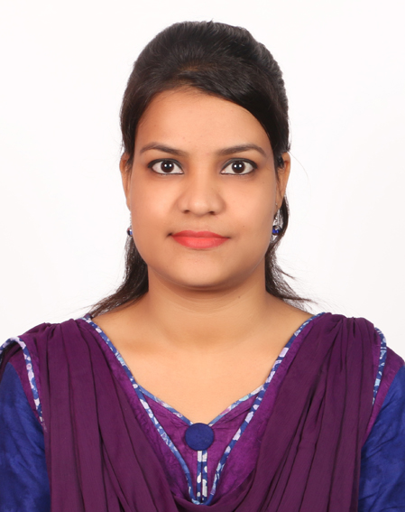
CURRICULUM VITAE OF

FATIMA PERVIN
Holding no: 24, Nayanshuka Biswaspara
P.O: Namoshankarbati
P.S: Chapai Nawabganj (Sadar)
Chapai Nawabganj 6300, Bangladesh
Cell: +8801736844401
E-mail: fpbonna@gmail.com [[
Career Objectives

To grow and excel as a professional in the development sector through innovative thinking and hard working attitude.
Educational Qualification

[
Bachelor of Laws (LLB)
Institute: National University
Major: Law
Year: 2016
Result: Second class(45%)
Masters of Arts (MA)
Institute : National University
Major : Bengali
Year : 2012
Result : Second Class(55.5%)

Bachelor of Arts (BA)
Institute : National University
Major : Bengali
Year : 2011
Result : Second Class(51%)

Higher Secondary Certificate (HSC)
Institute : Chapai Nawabganj Govt College
Board : Rajshahi
Group : Arts
Year : 2007
Result : 4.00 (in the scale of 5.00)

Secondary School Certificate (SSC)
Institute : Green View High School
Board : Rajshahi
Group : Science
Year : 2005
Result : 3.94 (in the scale of 5.00)
Relevant Professional Skills

- Excellent verbal and written communication skill.
- Consistently approach to work with energy and a positive‐constructive attitude.
- Leading teams effectively and shows conflict resolution skills.
Extra Curriculum Activities

- Member of Bissho Sahitto Kandro, Rajshahi Unit.
- Took part in many cultural competitions in local level.
- Member of SWAJAN(Volunteer Blood Donor Organization), Rajshahi College
Skill Training Received for Development Practice

Title/Subject of Training | Provided/Organized by | Location | Duration | Result
Modern Office Management & Computer Applications | Department of Youth Development | Rajshahi | July-December,  2015 | A
Dress Making | Department of Youth Development | Rajshahi | January-June, 2010 | A⁺
Computer Skill

- Modern Office Management & Computer Applications
- Internet Browsing & Multimedia
Language Skill

Language | Reading | Writing | Speaking
Bangla | Advance | Advance | Native
English | Advance | Moderate | Moderate
Biography

Name : Fatima Pervin
Father’s Name : Abul Quasem
Mother’s Name : Rokeya Begum
Present Address : Hoilding no: 24, Biswaspara, Nayanshuka
Post: Namoshankarbati
P.S: Chapai Nawabganj (Sadar)
Dist: Chapai Nawabganj, Bangladesh
Permanent Address : Hoilding no: 24, Biswaspara, Nayanshuka
Post: Namoshankarbati
P.S: Chapai Nawabganj (Sadar)
Dist: Chapai Nawabganj, Bangladesh
Date of Birth : 12 November, 1990
Religion : Islam
Nationality : Bangladeshi by birth
Marital Status : Single
Blood Group : B (+ve)
National ID No : 19907026610000007

Referees

Md. Rabiul Islam  Assistant Professor  Dept. of Bengali  Rajshahi College, Rajshahi  Phone: +8801716285736 | Md. Abdur Rahman  Assistant Professor  Dept. of Bengali  Rajshahi College, Rajshahi  Phone: +8801714331898

Sincerely
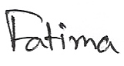


Fatima Pervin

